Cybersecurity Risk Assessment
Prepared for
Emerald Financial Solutions Ltd
Prepared by
Thenuki Munasinghe
Junior Cybersecurity Consultant
Date: 21/07/2026
July 2026

1.1 Company Details
ITEM | INFORMATION
Company Name | Emerald Financial Solutions Ltd
Industry | Financial Services
Location | Dublin, Ireland
Employees | 45
Founded | 2018
CEO | Sarah O’Connor
Annual Revenue | €7.5 million
Offices | 1
Customers | Approx 2500
Website | www.emeraldfs.ie

1.2 Company Departments
What We Do:
Emerald Financial Solutions Ltd is a medium-sized financial consultancy based in Dublin, Ireland. The company provides financial planning, mortgage advice, investment guidance and insurance services to individuals and small businesses. It employs 45 staff members and manages confidential customer financial information using cloud-based and on-premises systems.
Department | Employees
Management | 4
Finance | 8
Customer Support | 10
Sales | 12
Human Resources | 3
IT | 5
Compliance | 3
Total | 45
1.3 Office Information
Office Layout
The office contains:
- Reception
- Meeting Room A
- Meeting Room B
- Open-plan office
- Finance office
- IT office
- Server room
- Kitchen
- Storage room

Business Hours:
Monday–Friday
9:00 AM–5:30 PM
Hybrid working:
- 3 days in office
- 2 days remote
1.4 Customer Information
Customers:
The company serves:
- Individuals
- Small businesses
- Mortgage applicants
- Investment clients
Average customer records:
Approximately 2,500
1.5 Information Handled
What information does the company store?
Information Stored | Sensitivity
Customer Names | High
Addresses | High
Phone Numbers | Medium
Bank Account Details | Critical
Mortgage Documents | Critical
Employee Payroll | High
HR Records | High
Emails | Medium
1.6 Business Goals & Values
Company Goals:
- Protect customer information
- Maintain regulatory compliance
- Improve cybersecurity maturity
- Reduce phishing attacks
- Ensure business continuity
Company Values:
- Integrity
- Security
- Innovation
- Customer Trust
1.7 Technology Overview
Company Technologies:
Technology | Used For
Microsoft 365 | Email and collaboration
Windows 11 | Employee laptops
Microsoft Teams | Meetings
SharePoint | Document storage
VPN | Remote working
Wi-Fi | Office connectivity
File Server | Shared company files

Employees:
- Every employee has a laptop.
- Employees log in using company accounts.
- Hybrid working is supported through a VPN.
- Finance and HR staff have access to confidential information.
- IT manages user accounts and software updates.
Office Environment:

2.1 Office Overview:
Emerald Financial Solutions Ltd operates from a single commercial office in Dublin, Ireland. The office accommodates approximately 45 employees across management, finance, customer support, sales, human resources, IT and compliance functions.
The company operates a hybrid working model, with employees working both from the office and remotely. Employees who work remotely access company resources through Microsoft 365 and a company-managed VPN.
The office contains a reception area, meeting rooms, an open-plan working area, dedicated departmental spaces, an IT office, a restricted server room, storage facilities, a kitchen and staff welfare facilities.
Due to the sensitive nature of the financial and personal information handled by Emerald Financial Solutions Ltd, physical security is an important component of the company's overall cybersecurity strategy. Unauthorised physical access to devices, network infrastructure, documents or restricted areas could result in data theft, service disruption or compromise of confidential information.

2.2 Building Information:
Category | Details
Company | Emerald Financial Solutions Ltd
Location | Dublin, Ireland
Building Type | Commercial Office
Number of Floors | 1
Approx Employees | 45
Working Model | Hybrid
Office Hours | Mon-Fri, 9:00 – 17:30
Visitors | Customers, Suppliers and business partners
Main Entrance | Reception Area
Emergency Exit | 2
Server Room | Yes
IT Office | Yes
CCTV | Entrances and reception
Access Control | Staff Access Cards
Visitor Management | Reception Sign In
Security Alarm | Yes

2.3 Department Locations:

The office is divided into several functional areas based on the requirements of each department. Departments handling sensitive customer and employee information have restricted access where appropriate. The IT and server areas have additional physical security controls because they contain critical infrastructure and systems.

Department | Employees | Location | Access Level
Management | 4 | Management Office | Restricted
Finance | 8 | Finance Area | Staff Only
Customer Support | 10 | Open Office | Staff Only
Sales | 12 | Open Office | Staff Only
Human Resources | 3 | HR Office | Restricted
IT | 5 | IT Office | Restricted
Compliance | 3 | Compliance Office | Restricted
Reception | 2 | Main Entrance | Public/Staff
Server Room | - | IT Area | Highly Restricted

2.4 Physical Security Zones:

The office is divided into three physical security zones based on the sensitivity of information and systems located within each area.

Zone 1 – Public Area:
The public area consists primarily of reception and designated visitor areas. Customers and visitors may enter this area without requiring employee access credentials but must be accompanied when accessing restricted areas.

Zone 2 – Staff Area
The staff area includes the open-plan office, meeting rooms, kitchen and departmental workspaces. Access is restricted to authorised employees and approved visitors.

Zone 3 – Restricted Area
The restricted area includes the IT office and server room. Access is limited to authorised IT personnel and designated management staff. These areas contain critical network infrastructure and systems and therefore require stronger physical security controls.

Zone | Areas | Access
Public | Reception, visitor area | Visitors Permitted
Staff | Open Office, Meeting Rooms, kitchen | Employees
Restricted | IT office, Server Room | Authorized personnel Only

2.5 Existing Physical Security Controls:

Emerald Financial Solutions Ltd currently has several physical security controls designed to prevent unauthorised access to its premises and protect company assets. However, the assessment assumes that some controls require improvement or further monitoring.

Control | Current Status | Description
CCTV | Implemented | CCTV covers the main entrance and reception area
Staff Access Cards | Implemented | CCTV covers the main entrance and reception area
Visitor Sign-In | Implemented | CCTV covers the main entrance and reception area
Server Room Lock | Implemented | Server room is physically locked
IT Office Access | Implemented | Access restricted to IT staff
Security Alarm | Implemented | Alarm system protects the premises outside business hours
Fire Alarm | Implemented | Fire Detection system Installed
Fire Extinguishers | Implemented | Fire extinguishers located throughout office
Emergency Exits | Implemented | Fire extinguishers located throughout office
Laptop Locks | Implemented | Employees do not currently use physical laptop locks
Server Room CCTV | Not Implemented | No dedicated CCTV camera in server room
Visitor Escorting | Partially Implemented | Visitors are signed in but are not always escorted
Clean Desk Policy | Not Implemented | No formal policy currently exists

2.6 Physical Assets:

The office contains a range of physical assets that support business operations. Several of these assets are considered critical because their loss, theft or damage could affect the confidentiality, integrity or availability of company information.

Asset | Approx Quantity | Location | Importance
Employee Laptops | 45 | Staff Areas | High
Desktop PCs | 5 | Finance/ IT | High
Network Switches | 2 | Server Room | Critical
Firewall | 1 | Server Room | Critical
Server | 1 | Server Room | Critical
Network Storage/ NAS | 1 | Server Room | Critical
Wi-Fi Access Points | 3 | Office | High
Printers | 3 | Office | Medium
Company Phones | 45 | Staff | Medium
CCTV Cameras | 4 | Entrances/Reception | Medium
Backup Drives | 2 | Restricted Storage | High

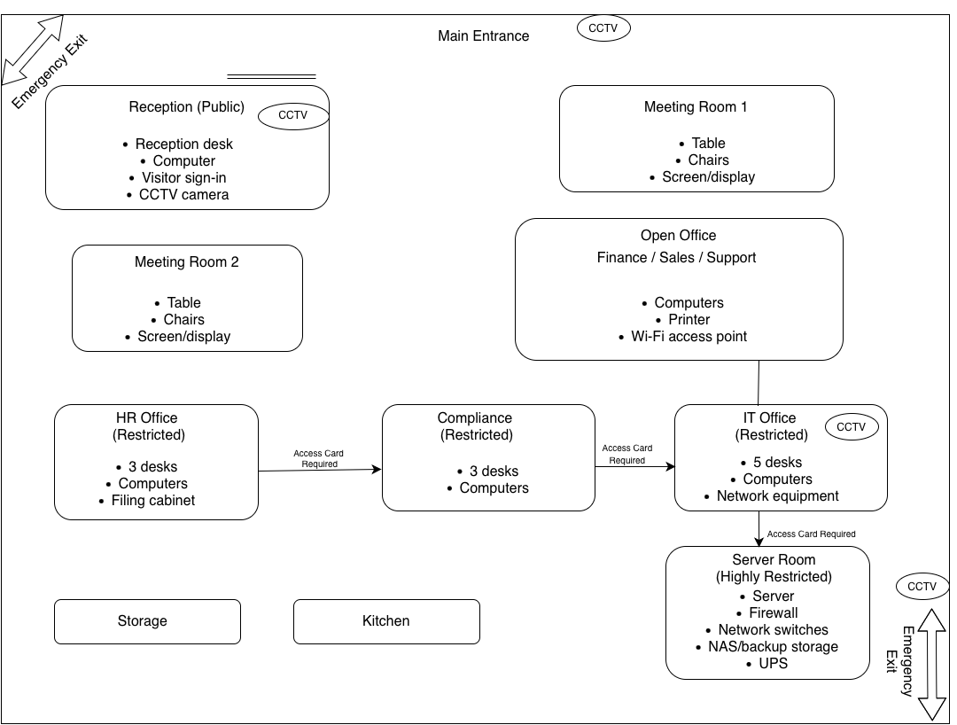

Figure 1: Physical layout of Emerald Financial Solutions Ltd

- The office layout demonstrates the separation between public, staff and restricted areas. Reception is positioned near the main entrance to control visitor access, while sensitive departments such as Human Resources and Compliance are located within restricted areas. The IT office and server room are positioned within the most secure area of the building, with access limited to authorised personnel. Critical infrastructure is therefore physically separated from general employee and visitor areas.

2.8 Physical Security Risk Identification

- A preliminary assessment of the office environment identified several physical security risks that could affect the confidentiality, integrity or availability of company information and systems. These risks will be incorporated into the wider cybersecurity risk assessment later in the project.

ID | Risk | Likelihood | Impact | Preliminary Rating
PHY-01 | Unauthorised person entering the office | Medium | High | High
PHY-02 | Laptop theft | Medium | High | High
PHY-03 | Tailgating through controlled entrance | Medium | High | High
PHY-04 | Unauthorised access to server room | Low | Critical | High
PHY-05 | Visitor accessing restricted areas | Medium | High | High
PHY-06 | Theft of confidential documents | Medium | High | High
PHY-07 | Fire damaging IT infrastructure | Low | Critical | High
PHY-08 | Water damage to server equipment | Low | Critical | High
PHY-09 | Unattended unlocked computers | Medium | Medium | Medium
PHY-10 | Loss of physical backup devices | Low | High | Medium

2.9 Preliminary Physical Security Recommendations

ID | Recommendation | Priority | Reason
REC-PHY-01 | Introduce mandatory visitor escorting | High | Prevent visitors accessing restricted areas
REC-PHY-02 | Install CCTV inside/near server room | High | Improve monitoring of critical infrastructure
REC-PHY-03 | Introduce laptop security locks | Medium | Reduce risk of device theft
REC-PHY-04 | Implement a clean desk policy | Medium | Reduce exposure of confidential information
REC-PHY-05 | Introduce quarterly access-card reviews | High | Remove unnecessary physical access
REC-PHY-06 | Store backup devices in a secure location | High | Protect backups from theft or damage
REC-PHY-07 | Introduce server-room environmental monitoring | High | Detect temperature/water-related risks
REC-PHY-08 | Provide staff security awareness training | High | Reduce social engineering and physical security risks

2.10 Physical Security Responsibilities

Role | Responsibility
CEO | Overall responsibility for business security
IT Manager | Protection of IT infrastructure
Facilities Manager | Building and physical security
HR Manager | Employee access management
Reception Staff | Visitor management
Employees | Following physical security policies
Security/Vendor | CCTV and alarm maintenance

2.11 Office Environment Conclusion

The physical environment of Emerald Financial Solutions Ltd contains several security controls designed to protect employees, information and IT infrastructure. However, the preliminary assessment identified opportunities to strengthen visitor management, restricted-area access, asset protection and environmental controls. These findings will be considered alongside the company's digital infrastructure during the wider cybersecurity risk assessment.

3.1 Network Infrastructure:

Emerald Financial Solutions Ltd operates a hybrid network infrastructure supporting both office-based and remote employees. The network is protected by a perimeter firewall and business router, with internal connectivity provided through managed switches and wireless access points. Critical infrastructure, including the file server and NAS backup system, is located within the restricted server room identified during the physical security assessment.

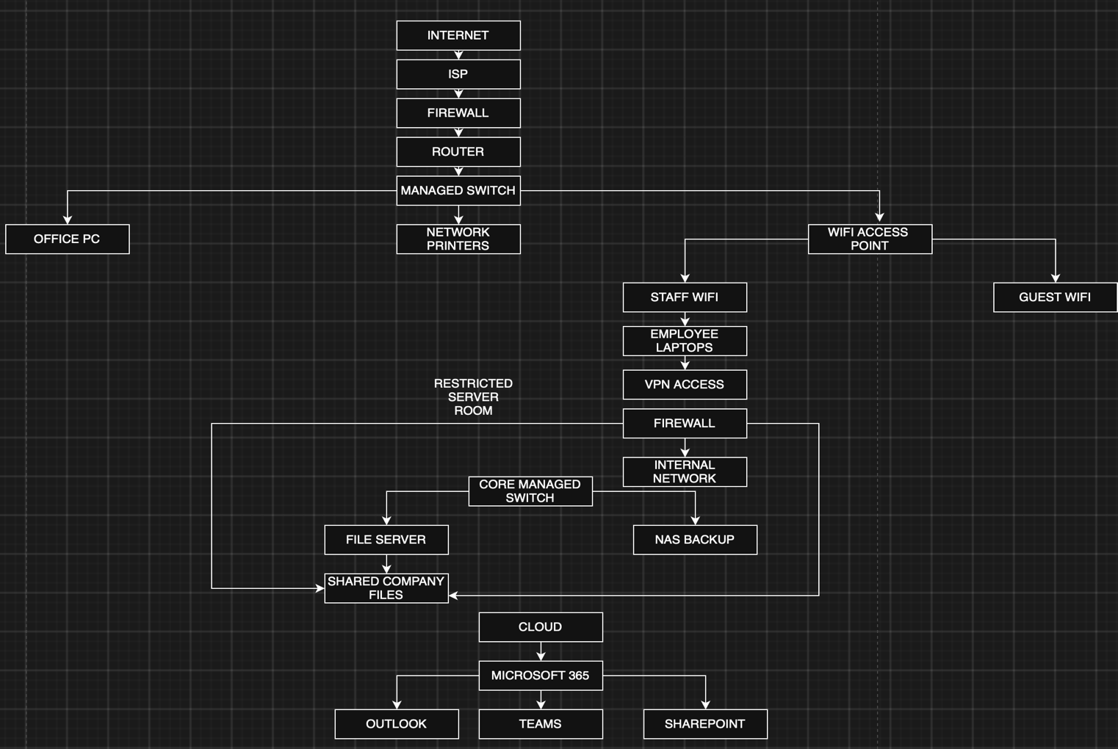

Figure 2: Network Infrastructure of Emerald Financial Solutions Ltd

The network architecture separates external internet traffic from internal company resources through the firewall. Employee devices access internal services through the managed network, while remote employees use the company VPN. Microsoft 365 provides cloud-based email, collaboration and document management services. Critical server infrastructure is located within the restricted server room, providing an additional layer of physical protection.

